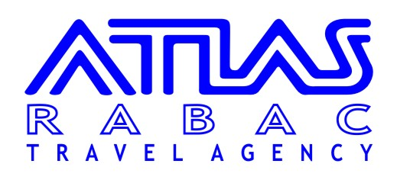

**** EXCURSIONS **** 2022****

DAY | IZLET | HRK | WITH | INCLUDED | FROM - TO
PONEDJELJAK  MONDAY  MONTAG | OPATIJA tour  SUNSET WITH DOLPHINS  By boat from Pula  VENEZIA VIA ROVINJ | 225,00  395,00  590,00 | Mini-bus  Bus, boat  Boat | Bus, guide  Transfer, boat, guide, dinner with drinks incl.  Boat ticket | 08:30-13:30  17:15-22:30  06:00-21:00
UTORAK  TUESDAY  DIENSTAG | NACIONAL PARK BRIJUNI  By boat from Pula | 585,00 | Bus, boat | Transfer, entrance, guide, boat | 09:30- 17:30
SRIJEDA  WEDNESDAY  MITTWOCH | SENTONA'S GARDENS  (wine and olive oil tasting- sightseeing of old town Labin) | 465,00 | Mini bus | Transfer, guide,  wine/olive oil tasting , ham and cheese | 09:30-13:30
ČETVRTAK  THURSDAY  DONNERSTAG | ISTRA-TOUR  (POREČ – KRCULI - ROVINJ)  VENEZIA VIA POREČ | 465,00  550,00 | Bus  Boat | Bus, lunch with drinks included, guide  Boat ticket | 08:30- 17:30  06:00-21:00
PETAK  FRIDAY  FREITAG | PULA tour | 225,00 | Bus | Bus, guide | 08:30-13:30

SUBOTA
SATURDAY
SAMSTAG

NEDJELJA  SUNDAY  SONNTAG | ROVINJ transfer  ROVINJ by night transfer | 195,00  225,00 | Mini-bus  Mini bus | Mini bus  Mini bus | 08:30-13:30  19:00-00:30
DAILY

ATLAS RABAC – Sv. Andrije, 4, c/o Hotel ALLEGRO, 052 872 268, E- mail: atlas-rabac@pu.t-com.hr – OIB 42711797360
Mob/WhatsApp Rosana 098 421 154 , Mob/WhatsApp: Euro 098 9133 829

1.1.Transfer - VENEZIA – 80,00 KN

1.2. Childrens discount:

Bus excursions:
Children from 0-2 years gratis
Children from 2-12 years-50% of price

Boat ticket for Venezia
Children from 0-7 years gratis
Children from 07-14 years-50% of price
Pets – 75,00 kn

Brijuni by boat i Sunset with Dolphins
Children from 0-7 years gratis – pay only transfer to Pula 80,00 kn
Children from 07-14 years-50% of price

Minimum persons for bus excursions: 4 pax

CANCELLATION CONDITIONS:
NO SHOW - 100 % OF THE PRICE/CANCELATION 24 HOURS BEFORE EXCURSION 50 % OF THE PRICE

In case of insufficient number of guest or due to unforeseen weather conditions the agency reserves the right to cancell the trip with the obligation to inform the parties.

ATLAS RABAC reserves the right to change prices

ATLAS RABAC
SVETOG ANDRIJE 4, C/O HOTEL ALLEGRO

TELEFON: 872 268
FAX: 872 958
E- mail: atlas-rabac@pu.t-com.hr
MOB / WHATS APP Rosana: 098 421 154 , Euro: 098 9133 829 (0-24 hours)

Privacy police (GDPR) you can find in our web site: www.atlas-istra.hr

ATLAS RABAC, putnička agencija D.O.O. uLICA Sv. Andrije 4, hotel Allegro, 52221 Rabac, Tel:(052)872 268 Fax:(052)872 958 E-mail:atlas-rabac@pu.t-com.hr ID-kod HR-AB-52-040143393 OIB:42711797360, RegistracijaTrgovački sud u Pazinu, MBS 040143393 Temeljni kapital:20.000,00 Kn uplaćen u cijelosti

